Several Functions

Look at this code:
def double(number):
return number * 2
def square(number):
return number * number
print("1: double\n2: square")
choice = input("Choice: ")
value = int(input("Number: "))
if choice == "1":
print("Result:", double(value))
else:
print("Result:", square(value))

What do you think this code will display?
Click or tap here to enter text.

Run the code. Compare the result with your prediction:
Click or tap here to enter text.

Let’s investigate! Answer the questions below:
- What separate job is performed by show_menu(), double() and square()?
Click or tap here to enter text.

- What happens if choice is compared with the number 1 even though input() returned the string "1"?
Click or tap here to enter text.

- What happens if the user enters 3, and why does the else branch call square() for that unexpected choice?
Click or tap here to enter text.

- If the choice is 1 and the number is 6, what result appears?
Click or tap here to enter text.

Several Functions

Look at this code:
def double(number):
return number * 2
def square(number):
return number * number
print("1: double\n2: square")
choice = input("Choice: ")
value = int(input("Number: "))
if choice == "1":
print("Result:", double(value))
else:
print("Result:", square(value))

Use the code above to help you. After completing each challenge below, run your program to test that it works correctly. Save each completed challenge program in a new file.

Programming Challenges

Challenge 1
Change square() into triple(), update menu route 2, and make choice 2 with value 6 display "Result:" 18.
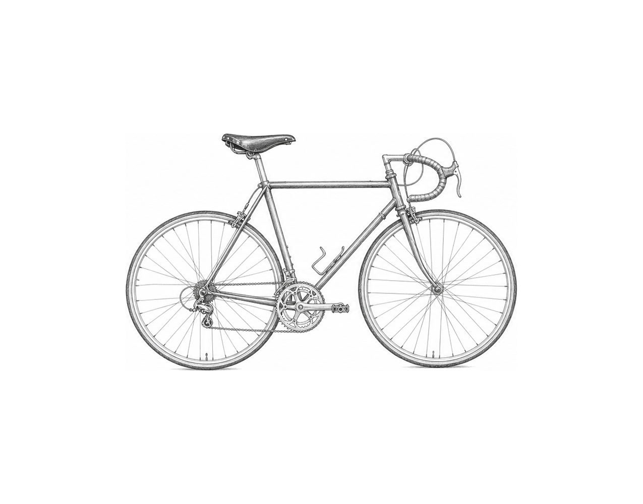

Challenge 2
Add a third function called half(number) that returns number / 2. Add menu route 3 and an invalid-choice message. Test 3 with 5 and x with 5.

Challenge 3
Build a measurement helper with separate functions to show a menu, calculate rectangle area, and calculate rectangle perimeter. The main program collects length and width, selects one calculation, and displays a labelled result; include an invalid route.

Several Functions

Fix the code!

This code has errors! Look closely at the code to find the problems:

def double(number):
number * 2
def square(number):
return number * number
value = 6
print(double)
print(squared(value))

Rewrite the whole program in the box below with fixes to the errors.
Click or tap here to enter text.

After you are confident that you fixed all the errors, copy the code from the box and run it.

Did it work correctly on your first try? Did you find all the errors?
Click or tap here to enter text.

